2.

CREATE TABLE People (

ID int identity,

FirstName nvarchar (20),

ParentName nvarchar (20),

LastName nvarchar (20),

ID_Father int,

ID_Mother int

)

CREATE TABLE Father (

ID_Father int identity,

FirstName nvarchar (20),

ParentName nvarchar (20),

LastName nvarchar (20),

)

INSERT INTO [dbo].[People] (FirstName, ParentName, LastName, ID_Father, ID_Mother)

VALUES (N'Дмитрий', N'Евгеньевич', N'Иванов', 1, 1),

(N'Александр', N'Владимирович', N'Греков', 2, 2),

(N'Дмитрий', N'Алексеевич', N'Золотов', 3, 3),

(N'Владислав', N'Андреевич', N'Красовский', 4, 4),

(N'Руслан', N'Евгеньевич', N'Дорин', 5, 5)

INSERT INTO [dbo].[Father] (FirstName, ParentName, LastName)

VALUES (N'Евгений', N'Олегович', N'Иванов'),

(N'Владимир', N'Петрович', N'Греков'),

(N'Алексей', N'Тимурович', N'Золотов'),

(N'Андрей', N'Юрьевич', N'Красовский'),

(N'Евгений', N'Олегович', N'Дорин')

SELECT * FROM [dbo].[People]

SELECT * FROM [dbo].[Father]

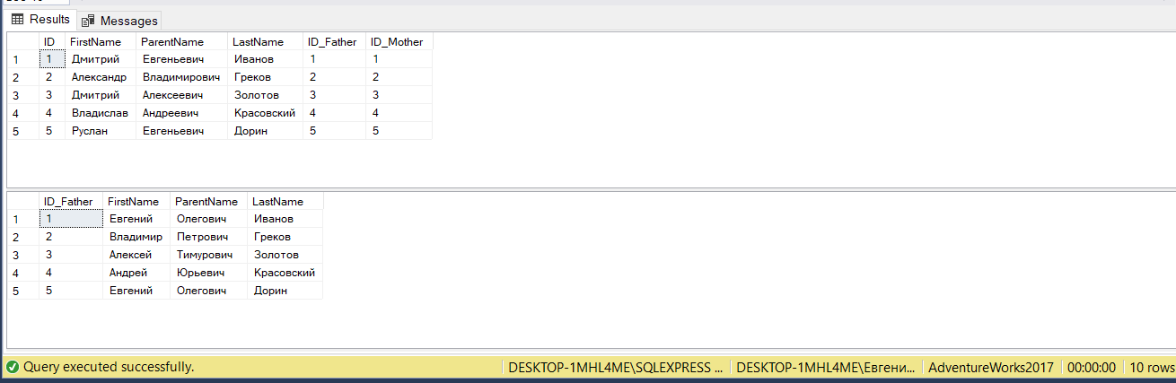

SELECT (concat ([People].[FirstName], ' ', [People].[ParentName], ' ', [People].[LastName])) as ФИО_son,

concat ([Father].[FirstName], ' ', [Father].[ParentName], ' ', [Father].[LastName]) as ФИО_father

FROM [People]

LEFT JOIN [Father] ON [People].[ID_Father]=[Father].[ID_Father]

WHERE [People].[FirstName] = N'Дмитрий'

